ASEAN DAY: FLAG HOISTING CEREMONY 2025

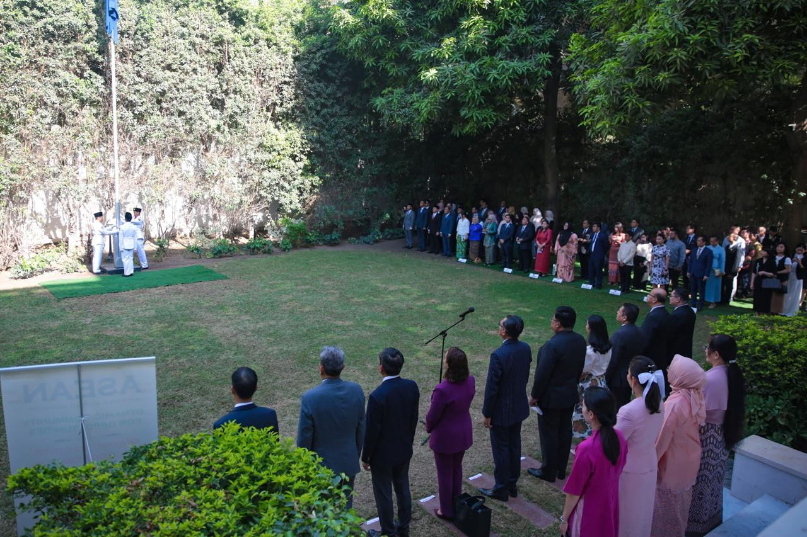

- On 20 August 2025, the ASEAN Committee in Cairo held a flag hoisting ceremony in conjunction with ASEAN Day.

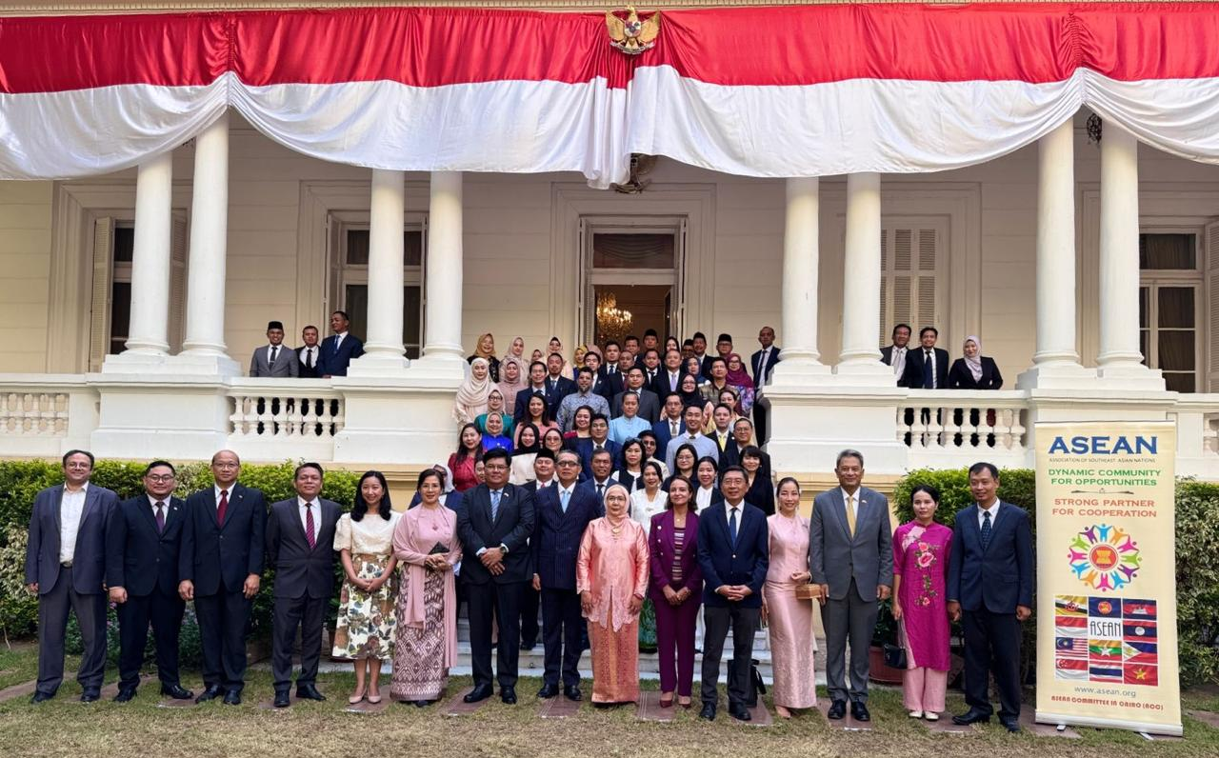
- The event was held at the Residence of Indonesian Ambassador in Cairo.

- All ASEAN Head of Missions (HoMs) and Chargé d’Affaires in Egypt attended the event.
******

